Steps to Create Game and Competition

**Login into Gameon Console**

1. Navigate to <https://developer.amazon.com/gameon/console/home>

2. Enter the prompted username and password for your Amazon Developer account

**Create a New Game**

1. Navigate to <https://developer.amazon.com/gameon/console/register>

2. Click on `Register New Game`

3. Enter Developer Name and Game Title and Click on `Register`

4. Notedown the credentials being shown which need to be configured in Backend API

5. To view the credentials of existing game Click on `view` in the existing game listing

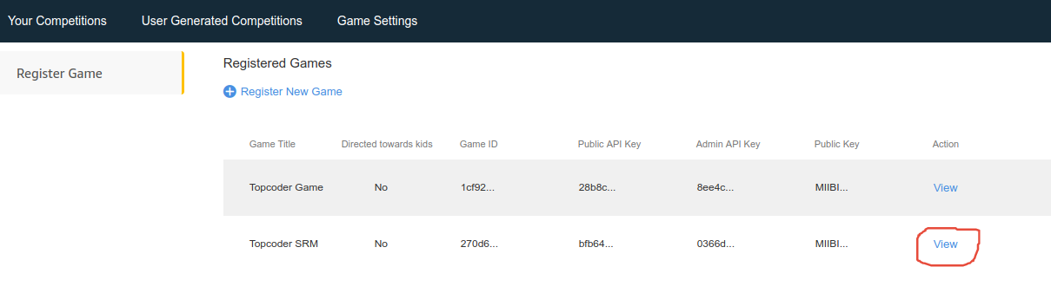

**Creating Competition**

1. After creating the game, set up the backend using the documentation in Backend Repo

2. Use Admin APIs to create prize types

3. Navigate to home page <https://developer.amazon.com/gameon/console/home> and Click on Create Competition

4. Create Competition UI is pretty simple and it’s easy to fill the details.

5. To enter prizes, You need to create prize types using Postman collection provided (Referred in Point #2)

6. Then create prizes and fill other details

Sample prize entry

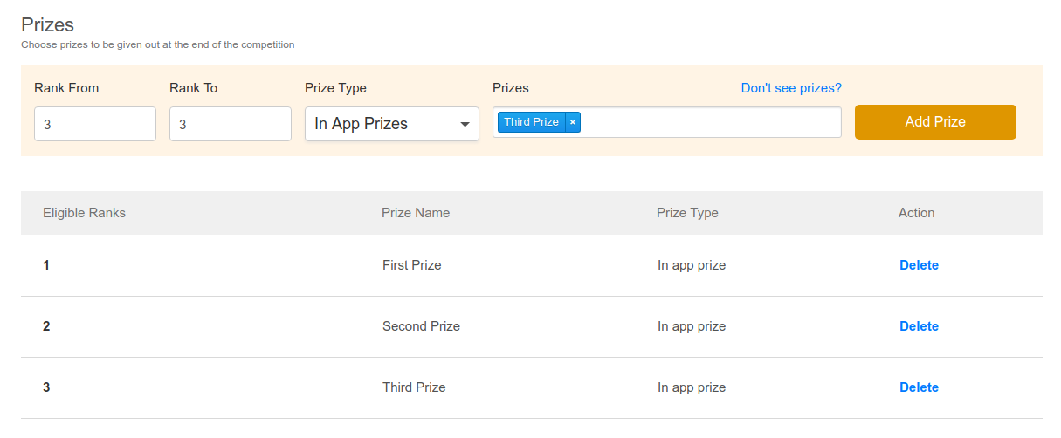

**Recurrence competition example**

Creating Simple Recurrence competition which repeats every Tuesday and closes after 5 occurences

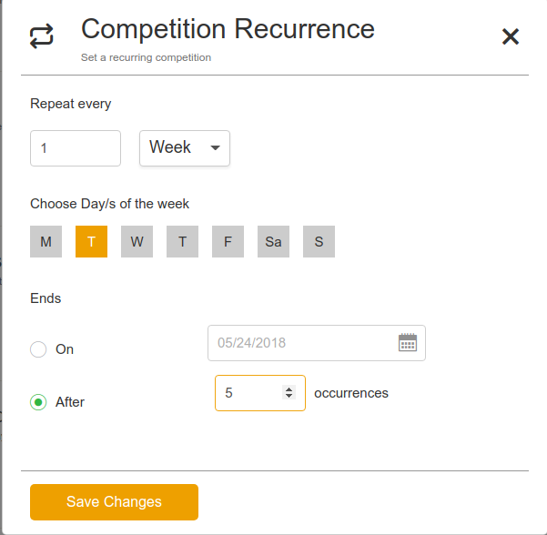

**Dashboard page**

1. After you create the recurring competitions ensure that atleast one competition is active.

